Employee Data Analysis using Excel

# STUDENT NAME: POORNASHREE H

# REGISTER NO : D8CAC6271A0A824A9504FAE6BD787644,122201842

# DEPARTMENT : B.COM (CORPORATE SECRETARYSHIP)

# COLLEGE : MEENAKSHI COLLEGE FOR WOMEN

Based on Department, Gender and

PROJECT TITLE

Employee Performance Analysis



FTE using Excel

AGENDA

1

.Problem Statement

2

.Project Overview

3

.End Users

4

.Our Solution and Proposition

3/21/2024

AnnualReview



5.

Dataset Description

6

.Modelling Approach

7

.Results and Discussion

8

.Conclusion

# PROBLEM STATEMENT

To analyze the performance of employees within an organization by examining various factors such as department, gender and full-time equivalent (FTE) status using Excel.



## PROJECT OVERVIEW

To analyze the performances of employees within an organization by examining various factors such as department, gender and full-time equivalent (FTE) status using Excel. This analysis will ultimately help the organization to improve the overall effectiveness of the workforce.



WHO ARE THE END USERS?

1. TEAM LEADERS AND SUPERVISORS
2. EMLOYEES
3. EXECUTIVE LEADERSHIP
4. BUSINESS ANALYSTS
5. RECRUITERS

6

OUR SOLUTION AND IT'S VALUE PROPOSITION

PIVOT TABLE – SUMMARY OF

EMPLOYEE PERFORMANCE



BAR DIAGRAM – FINAL REPORT

 7

# Dataset Description

EMPLOYEE DATA SET – NAN MUDHALVAN PORATAL 9 FEATURES IN EXCEL:

EMPLOYEE ID – ALPHANUMERIC (TEXT)

NAME – ALPHABETICAL (TEXT)

GENDER – ALPHABETICAL (TEXT)

DEPARTMENT – ALPHABETICAL (TEXT)

SALARY - NUMERICAL

START DATE – ALPHANUMERIC (TEXT)

FTE - NUMERICAL

EMPLOYEE TYPE – ALPHABETICAL (TEXT) EMPLOYEE LOCATION – ALPHABETICAL (TEXT)

3 FEATURES USED:

DEPARTMENT – ALPHABETICAL (TEXT)

FTE - NUMERICAL

GENDER – ALPHABETICAL (TEXT)

## THE "WOW" IN OUR SOLUTION

➢Effective data visualization makes it easier to present complex data in an engaging and understandable way.

➢Well-presented data can have a significant impact on decision-makers, helping to drive change and innovation.

3/21/2024

AnnualReview



9

# MODELLING

STEP-1

DOWNLOAD THE EMPLOYEE DATASET AND OPEN

THE EMPLOYEE DATASET IN EXCEL.

STEP-2

SELECT THE ENTIRE DATA AND CLICK ON INSERT

AND CLICK ON PIVOT TABLE TO CREATE PIVOT TABLE.

STEP-3

DRAG THE NEEDED DATA AND CREATE A PIVOT

TABLE.

10

STEP-4

## SELECT THE PIVOT TABLE AND CLICK ON

INSERT.

STEP-5

NOW CLICK ON THE CHART THAT YOU WANT.

STEP-6

THE CHART IS CREATED.

# RESULTS 1.TABLE

12

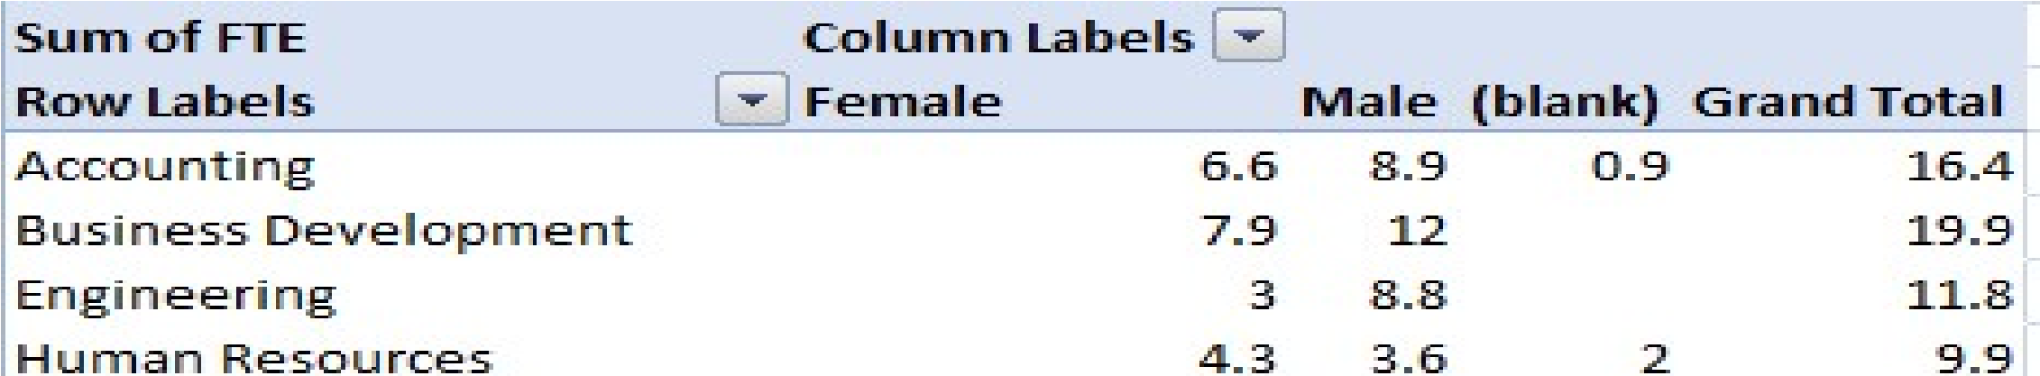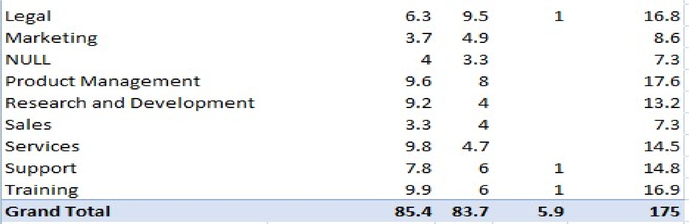

# 2.BAR DIAGRAM

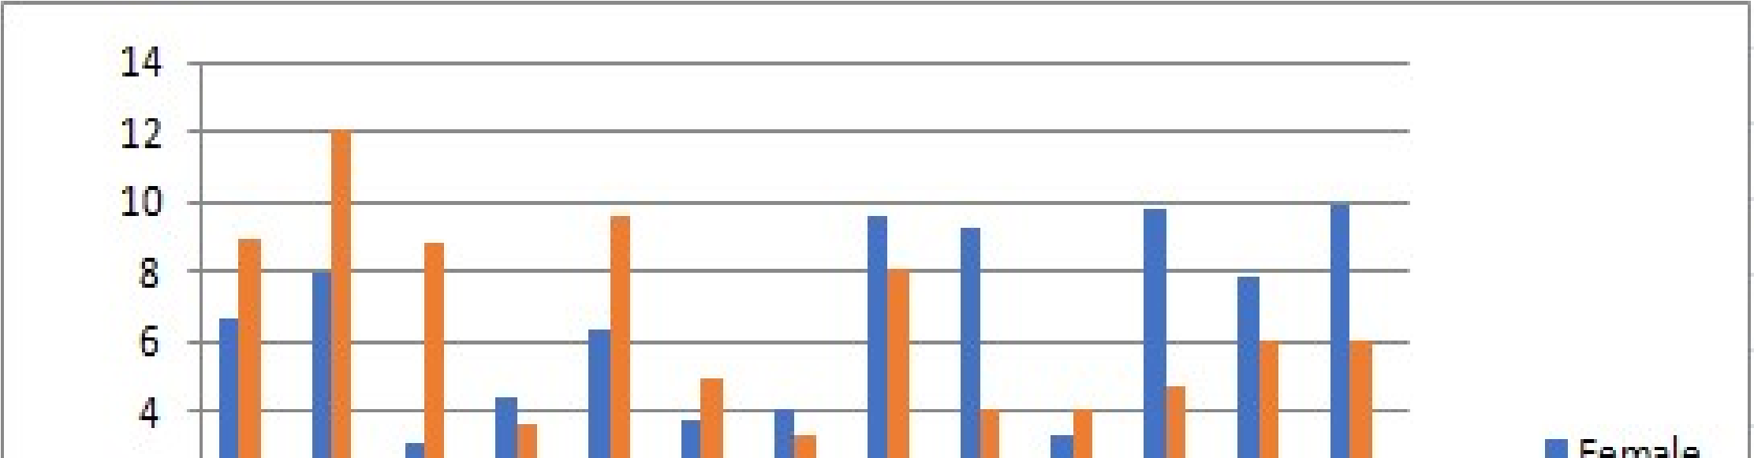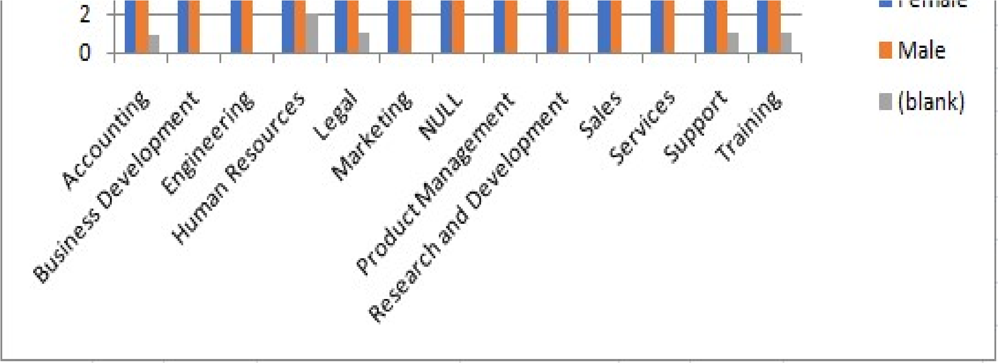

Conclusion

Based on the performance analysis conducted across various departments, genders, and FTE statuses, several key insights have emerged which could contribute to the overall efficiency of the organization. Overall, the analysis provides a clear picture of performance dynamics within the organization, highlighting areas of strength and opportunities for targeted improvements.